Business Plan
Click or tap here to enter text.
Click or tap here to enter text.
Click or tap to enter a date.

Click or tap here to enter text.
Click or tap here to enter text.
Click or tap here to enter text.
Click or tap here to enter text.

Table of Contents

Executive Summary

Business or Company Description

Products and Services

Market Analysis

Marketing Plan

Management and Personnel

Operational Plan

Financial data

Supplemental Documentation

Instructions

What is a business plan?

A written outline that evaluates all aspects of the economic viability of a business venture.
Starting a business without a business plan is like leaving for a road trip without a map. You need to know where you are going and HOW you plan to get there. Your business plan is your road map to success. It is a detailed road map of your business venture written to ensure strategic success

Things to consider as you build your business plan:

Writing a business plan answers the “5 W’s and H” questions for the reader.
Your business plan should address:
- WHO you are as a business.
- WHO will guide the company through its growth stages?
- WHAT your company does.
- WHAT sets your company apart from the competition?
- WHERE does your business operate?
- WHERE do you find your clients?
- WHEN you will open, hire, expand, and advertise. Every business needs a timeline.
- WHY your business is better than your competitors are.
- WHY customers will choose your business.
- HOW you operate, advertise, and most importantly, HOW you will succeed.

Strong Business Plans Have:

- A sound business concept
- An understanding of your business’ target market
- A healthy, growing and stable industry
- Capable management
- Able financial control
- A consistent business focus

Weak Business plans have:

- High focus on the product and/or services
- Little familiarity with target market
- Financial projections beyond industry norms
- Unrealistic growth projections
- High reliance on specialty engineering, one large client, or one supplier

Business or Company Description

Mission Statement
Usually 30 words or fewer; explains your reason for being and some guiding principles.

Click or tap here to enter text.

Goals and Objectives
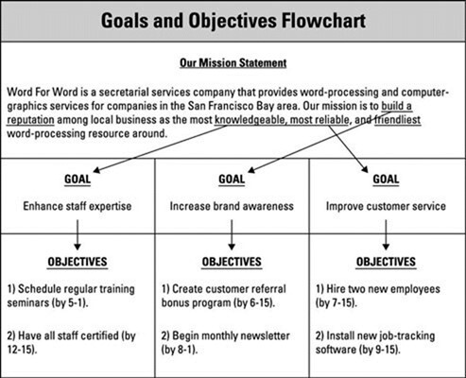

Goals are where you want your business to be in 1, 2, 3 -5 years. This is a “WHAT” question.
Objectives are progress markers along the way to goal achievement. This is a “HOW” question.

Click or tap here to enter text.

Business Philosophy
What are the core values for your business? What fuels your journey and motivates you to build this business? This is often a statement of passion. This is a “WHY” question.

Click or tap here to enter text.

Industry Scope
Briefly describe the industry you operate in and the customer you serve (you will do this more thoroughly in the marketing section). This is a “WHO” question.

Click or tap here to enter text.

Strengths
Describe your most important company strengths and what differentiates your company from your competition. What is your competitive advantage over the competitors? How does your product/service do a better job of meeting your customer’s needs than others?
This is a “WHAT” question.

Click or tap here to enter text.

Business Formation
Describe your legal form of ownership. This is a “WHAT” question.

Click or tap here to enter text.

Products and Services

Product Description
Describe in depth the products you offer (leave technical specifications, documents, drawings, photos, sales brochures, or other bulky items in the supplemental documentation). This is a WHAT question.

Click or tap here to enter text.
Service Description
Describe in depth the services you offer (leave technical specifications, documents, drawings, photos, sales brochures, or other bulky items in the supplemental documentation). This is a WHAT question.

Click or tap here to enter text.
Pricing
What is your pricing model? What does it cost someone to be a customer or client? Pricing, fee, or leasing structures.
Click or tap here to enter text.

Competitive Advantages
Does your product/service solve a problem for your customer? How does your solution to that problem meet the needs of your customer better than others? Detail what factors will give you competitive advantages or disadvantages. This is a good place to describe anything that makes your product/service unique; things like level of quality or proprietary information. If you have identified a direct competitor this is a great place to describe how you will overcome this challenge.

Click or tap here to enter text.

Market Analysis
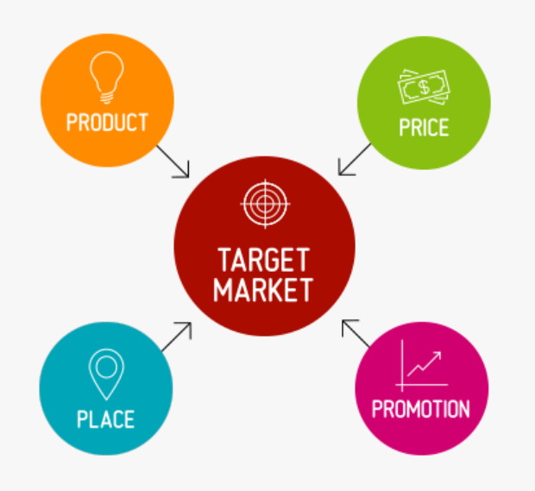

Target Market
Describe your target customer. Include details such as age, race, gender, ethnicity, income level, location, social class and occupation, education, and other industry specific factors that your customer may embody. Include a detailed description of your target market.

Click or tap here to enter text.

Describe who your target customer is not. It is vital to understand who is NOT your customer.

Click or tap here to enter text.

Market Trends
Discuss trends in the target market – growth trends, customer preferences, and trends in product development.

Click or tap here to enter text.

Describe current demand and discuss growth potential and opportunity.

Click or tap here to enter text.

Discuss barriers to entry and how you will overcome those.

Click or tap here to enter text.

Detail your competition by listing your major competitors, how and what they will compete with you on, indirect competitors, and how your product or service will compare.

Click or tap here to enter text.

Marketing Plan

List descriptions and explanations of the marketing channels you will use detailing why they will be most effective.

Click or tap here to enter text.

Start Up Marketing
Discuss how you will budget your marketing efforts monetarily, with time, and with personnel. These costs may be different during your start-up period, be certain to describe initial costs.

Click or tap here to enter text.

On Going Marketing
Discuss how you will budget your marketing efforts monetarily, with time, and with personnel.

Click or tap here to enter text.

Management and Personnel

Applicable Experience
Discuss the personal history of the principals including business background, past experiences with tracking success, responsibilities, and capabilities, educational background, and identifying information. Focus on how the principals’ experience is the right fit for building and leading the company.

Click or tap here to enter text.

Personnel
Number of employees, type of labors, enlisting labor, pay structure, training methods and requirements, onboarding, policies, and procedures, job descriptions.

Click or tap here to enter text.

Duties and Responsibilities
Organizational chart; list who will do what and why. This can be a description of how you will function during year and then how you would like to grow in the future. You can use this opportunity to create a timeline for the growth of your staff.

Click or tap here to enter text.

Salary and Benefits
Now that you have outlined which employee you will focus on hiring first, you will need to know what the type of talent you will need will cost. This can direct your timeline planning in your financials. Knowing the salary and benefit ranges for future hires will allow you know when you can afford to hire them. It is important to understand the true costs involved in hiring so that you can best judge when you are able to hire.

Click or tap here to enter text.

Resources
List any existing resources that you have in place and available to your business.

Click or tap here to enter text.

Operational Plan

Production: Production techniques and costs, quality control, customer service, inventory control, product development.

Click or tap here to enter text.

Location: Amount of space, type of building, zoning, power and other utilities, requirements for access.

Click or tap here to enter text.

Legal environment: Licensing and bonding requirements, permits, health, workplace, or environmental regulations, industry or profession specific regulations, zoning or building code requirements, trademarks, copyrights, or patents.

Click or tap here to enter text.

Suppliers
Names and addresses, type and amount of inventory furnished, credit and delivery policies, history and reliability.

Click or tap here to enter text.

Executive Summary
When completed this section should be 1-2 pages in length. This is an objective overview and needs to be written last. Think of this section as a short sales presentation that tells the reader what you are doing, why and how you are doing it, why you are qualified, and what sets you apart in the marketplace.

Click or tap here to enter text.

Business concept: Describe the product and the market it will serve.

Click or tap here to enter text.

Financial features: Summarize information from financial statements and forms that document the viability of your business and its soundness as an investment.

Click or tap here to enter text.

Financial requirements: Indicate the cost of the entire project (investment and working capital) and how you plan to finance the business. This can include statements about prior investments made to build the business foundation.

Click or tap here to enter text.

Address the current state of your business and its history. Where are you currently in the process of forming or building your business? What steps have you taken to arrive at this moment?

Click or tap here to enter text.

Market: Describe how you will operate in the market and what your competitive advantages are. How will your business meet the needs of your consumer better or differently than other existing businesses? What is your ‘secret sauce’ that keeps bringing customers back to you?

Click or tap here to enter text.

Management: Include qualifying information about management and key personnel. If you will be hiring persons to supplement your knowledge of the market or consumer (IE someone that has helped to manage a similar business) you should clearly state these intentions.

Click or tap here to enter text.

Detail your road to success by projecting growth. Sum up your numbers here. Use your projections or existing sales data to tell a story to the read of HOW your business will strategically grow and sustain for the next 1 -3 years.

Click or tap here to enter text.

Financial Data

You will need to complete and attached to your final draft:
- Personal financial statement
- Three years of financial projections or statements
(profit and loss, balance sheet, statement of cash flows)
- Break-even analysis

Supplemental Documentation to be attached to final draft:

- Resume or CV
- Industry studies
- Blueprints and plans
- Maps and photos of location
- Marketing materials
- Quotes or estimates
- Legal documents relevant to the business
- Letters of intent
- Lease agreements

